Missouri University of Science and Technology BS Elec Eng
Effective Catalog Year 2025 Approved 2025

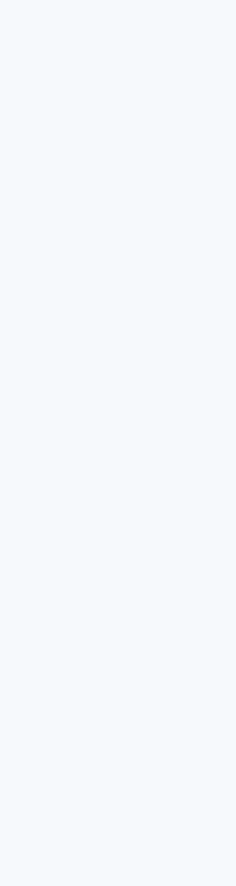
Freshman Year Sophomore Year Junior Year Senior Year

Fall Spring Fall Spring Fall Spring Fall Spring
Math
1214
4 hrs
or
Math
1210/ 1211
4/4 hrs
4 hrs

4 hrs
Math
2222
4 hrs

Math
3108
3 hrs

Math
3304
3 hrs

Stat 3117
3 hrs

Elec Eng Elective C
3 hrs

Elec Eng Power Elective and
Lab
4 hrs

Math
1215
4 hrs

Elec Eng Elective E
3 hrs

Elec Eng 3600
4 hrs

Elec Eng 3100 and
3101
4 hrs

Comp Eng 2210 and
2211
4 hrs

Elec Eng Elective B
3 hrs

Elec Eng 2120
3 hrs

Mech Eng 1720
3 hrs

Fresh Eng 1100
1 hr

Elec Eng Senior Project II 4097
3 hrs

Elec Eng Elective D
3 hrs

Elec Eng Elective A
3 hrs

Gen Ed Elective
3 hrs

Chem 1310 and 1319
5 hrs

Elec Eng 3320 and
3321
4 hrs

Elec Eng 2100 and
2101
4 hrs

Elec Eng 2410 and
2411 hrs

* ELEC ENG 4096
* SPEECH 1185
* STAT 3117

Elec Eng 3430 and
3431
4 hrs

Physics 2135
4 hrs

Hist
1200 or 1300 or 1310 or
Pol Sci
1200
3 hrs

Elec Eng Senior Project I 4096
1 hr

Physics 1135
4 hrs

Speech 1185
3 hrs

Pro Dev Elective
3 hrs

Eng Sci Elective
3 hrs

* COMP ENG 2210
* ECON 1100 or ECON 1200
* COMMUNICATION ELECTIVE
* At least three of the following: ELEC ENG 3500 or ELEC ENG 3540; ELEC ENG 3320, ELEC ENG 3430, ELEC ENG 3600 or ELEC ENG 3100
Gen Ed Elective
3 hrs

Free Elective
3 hrs

Gen Ed Elective
3 hrs

Comp Sci 1500
3 hrs

English
1120
3 hrs

Commun Elective
3 hrs

Free Elective
3 hrs

17 hours
15 hours
15 hours
17 hours
17 hours
14 hours
17 hours
16 hours

Core courses with C or better requirement Core courses with advancement exam requirement

Single line and bulleted lists denote course prerequisites. Course prerequisites and elective requirements are listed on the following page.

If you Drop Elec Eng 2100, Elec Eng 2410, Comp Eng 2210, etc., you must also drop the co-requisite laboratories.

Disclaimer: This summary may assist students and advisors in scheduling classes. This is not a complete description of the graduation requirements for a BS Elec Eng degree. See the Missouri S&T undergraduate catalog and the Elec Eng undergraduate handbook for a complete description of graduation requirements.

Course Prerequisites and Elective Requirements

MATH 1215
- MATH 1214 or MATH 1210/1211

MATH 2222
- MATH 1215

MATH 3304
- MATH 2222

MATH 3108
- MATH 1215
- MATH 2222

STAT 3117 or STAT 3115 or STAT 5643
- MATH 2222
.
COMP SCI 1500

PHYSICS 1135
- MATH 1214 or MATH 1210/1211

PHYSICS 2135
- PHYSICS 1135
- MATH 1215

ELEC ENG 2100/2101
- MATH 1215

ELEC ENG 2120
- ELEC ENG 2100/2101
- PHYSICS 2135
- INCLUDES SOPHOMORE SEMINAR

ELEC ENG 2410/2411
- ELEC ENG 2100

ELEC ENG 3100/3101
- ELEC ENG 2120
- COMP ENG 2210

ELEC ENG 3320/3321
- ELEC ENG 2120
- ELEC ENG 2410
- MATH 3304

ELEC ENG 3430/3431
- ELEC ENG 2120
- ELEC ENG 2410

ELEC ENG 3600
- ELEC ENG 2120
- ELEC ENG 2101
- PHYSICS 2135
- MATH 3304

ELEC ENG 4096
- COMP ENG 2210
- ECON 1100 or ECON 1200
- COMMUNICATION ELECTIVE (ENGLISH 3560 or ENGLISH 1160)
- At least three of the following: ELEC ENG 3500 or ELEC ENG 3540; ELEC ENG 3320, ELEC ENG 3430, ELEC ENG 3600 or ELEC ENG 3100

ELEC ENG 4097
- ELEC ENG 4096
- STAT 3117 (or STAT 3115 or STAT 5643)
- SP&M S 1185

ELEC ENG POWER ELECTIVE
- ELEC ENG 3500/3501 or ELEC ENG 3540/3541

COMMUNICATION ELECTIVE
- ENGLISH 3560 or ENGLISH 1160 (Prerequisite ENGLISH 1120)

ELEC ENG ELECTIVES A, B, AND C
- Students must choose from ELEC ENG 56XX, ELEC ENG 3500, ELEC ENG 3540, ELEC ENG 3410, ELEC ENG 3250, ELEC ENG 3340, ELEC ENG 3440, ELEC ENG 3120, and COMP ENG 3150. Only one ELEC ENG 56XX course may be used.

ELEC ENG ELECTIVE D
- Students must choose a 4000 or 5000-level Comp Eng or Elec Eng course with at least a 3-hour lecture component. This normally includes all Comp Eng and Elec Eng 4000 or 5000-level courses except Comp Eng or Elec Eng 4000, 4099, 4096, and 4097 or Comp Sci 5000, 4010, 5600, and 4099.

ELEC ENG Elective E
- Students must choose any 3XXX-level or above ELEC ENG or COMP ENG course except ELEC ENG 3002, ELEC ENG 38XX, ELEC ENG 4096, ELEC ENG 4097, and ELEC ENG 5070 and COMP ENG 3002, COMP ENG 38XX, COMP ENG 4000, COMP ENG 4096, COMP ENG 4097, and COMP ENG 5070.

ENG SCI ELECTIVE
- Students must take one of: MECH ENG 2340, MECH ENG 2519, MECH ENG 2527, PHYSICS 2305, PHYSICS 2311, PHYSICS 2401, NUC ENG 3103, CHEM 2210, BIO SCI 2213, or BIO SCI 2223. The following pairs of course are substitutions: CIV ENG 2200 and MECH ENG 2350 or ENG MGT 2110 and ENG MGT 3310.

PROFESSIONAL DEVELOPMENT (PRO DEV) ELECTIVE
- Students must take one of the following courses: BUS 5980, ECON 4430, ECON 5337, ENG MGT 2310, ENG MGT 3320, ENG MGT 4110, ENG MGT 5514, PHIL 3225

GENERAL EDUCATION ELECTIVE
- Must fulfill the Missouri S&T general education requirements applicable to the student's catalog year. These requirements are specified in the current catalog.

